Chapter-5
Coordinate systems

Cartesian coordinates:

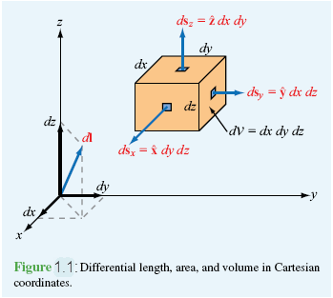
Figure: Differential length, area, and volume in Cartesian coordinates.

Cartesian variables
Vector representation,
Magnitude of is ,
Position vector, $\vec{OP}=\hat{x}x_{1}+\hat{y}y_{1}+\hat{z}z_{1}$for
Base vector properties: and
Dot product
Cross product
Differential length, $d\vec{l}=\hat{x} dx+\hat{y} dy+\hat{z} dz$
Differential surface area, $d{\vec{s}}_{x}=\hat{x} dy dz, d{\vec{s}}_{y}=\hat{y} dz dx, d{\vec{s}}_{z}=\hat{z} dx dy$
Differential volume, $dV=dx dy dz$

Cylindrical coordinates:
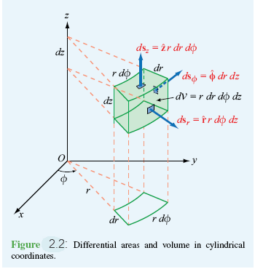 | 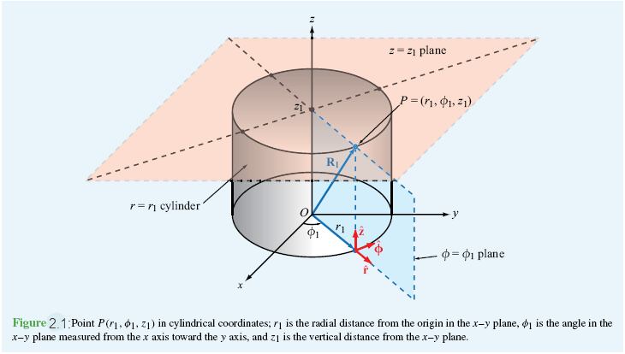
Figure: Differential length, area, and volume in cylindrical coordinates. | Figure: Point $P\left(r_{1},ϕ_{1},z_{1}\right)$ in cylindrical coordinates; $r_{1}$is the radial distance from the origin in the $xy$plane, $ϕ_{1}$is the angle in $xy$ plane measured from the $x$ axis toward the $y$ axis, and $z_{1}$ is the vertical distance from the $xy$ plane.

Cylindrical variables
Vector representation,
Magnitude of is ,
Position vector,$\vec{OP}=\hat{r}r_{1}+\hat{z}z_{1}$ for
Base vector properties: and
$\hat{r}×\hat{ϕ}=\hat{z}, \hat{ϕ}×\hat{z}=\hat{r}, \hat{z}×\hat{r}=\hat{ϕ}$
Dot product
Cross product
$$\overset{⃑}{A} ×\overset{⃑}{B}= \left|\begin{matrix}\hat{r} & \hat{ϕ} & \hat{z} \\ A_{r} & A_{ϕ} & A_{z} \\ B_{r} & B_{ϕ} & B_{z}\end{matrix}\right|=\hat{r}\left(A_{ϕ}B_{z}-A_{z}B_{ϕ}\right)- \hat{ϕ} \left(A_{r}B_{z}-A_{z}B_{r}\right)+\hat{z}\left(A_{r}B_{ϕ}-A_{ϕ}B_{r}\right)$$
Differential length, $d\vec{l}=\hat{r}dr+\hat{ϕ} rdϕ+\hat{z} dz$
Differential surface area, $d{\vec{s}}_{r}=\hat{r} rdϕ dz, d{\vec{s}}_{ϕ}=\hat{ϕ} drdz, d{\vec{s}}_{z}=\hat{z} dr rdϕ$
Differential volume, $dV=dr rdϕ dz$

Spherical coordinates:

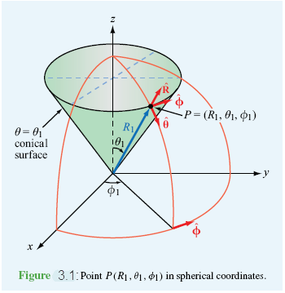 | 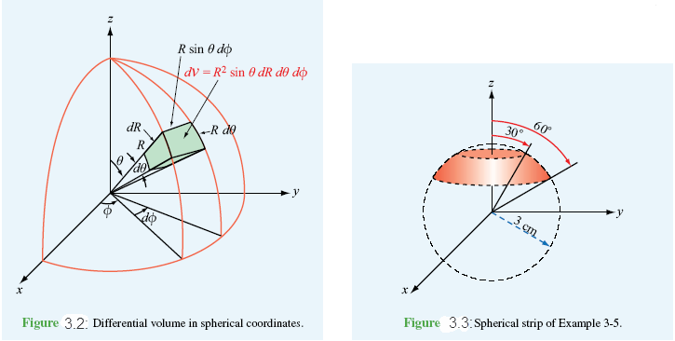
Figure: point $P(R_{1}, θ_{1}, ϕ_{1})$ in spherical coordinates. | Figure: Differential volume in spherical coordinates.

Spherical variables
Vector representation,
Magnitude of is ,
Position vector, $\vec{OP}=\hat{R}R_{1}$ for
Base vector properties: and
Dot product
Cross product
Differential length, $d\vec{l}=\hat{R} dR+\hat{θ} R dθ+\hat{ϕ} R\sin{θ} dϕ$
Differential surface area, $d{\vec{s}}_{R}=\hat{R} Rdθ R\sin{θ} dϕ, d{\vec{s}}_{θ}=\hat{θ} dR R\sin{θ} dϕ,$
$d{\vec{s}}_{ϕ}=\hat{ϕ} dR Rdθ$
Differential volume, $dV=dR R dθ R\sin{θ dϕ}$
Transformation (Cartesian coordinates to cylindrical and vice versa):
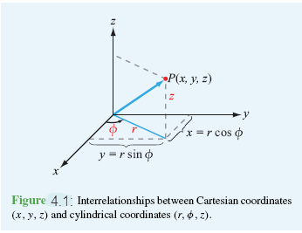 | 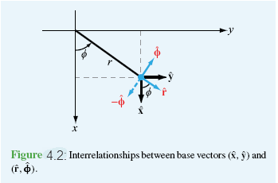
Figure: Interrelationships between Cartesian coordinates $(x,y,z)$ and cylindrical coordinates$(r,ϕ,z)$. | Figure: Interrelationships between base vectors $(\hat{x}, \hat{y})$ and $(\hat{r},\hat{ϕ})$.

We know,
;
 |  | $$A_{r}$$ | $$A_{ϕ}$$ | $$A_{z}$$
 |  | $$\hat{r}$$ | $$\hat{ϕ}$$ | $$\hat{z}$$
$$A_{x}$$ | $$\hat{x}$$ | $$\cos{ϕ}$$ | $$-\sin{ϕ}$$ | 0
$$A_{y}$$ | $$\hat{y}$$ | $$\sin{ϕ}$$ | $$\cos{ϕ}$$ | 0
$$A_{z}$$ | $$\hat{z}$$ | 0 | 0 | 1

That is,
$\hat{x}=\hat{r} cos{ϕ-\hat{ϕ}\sin{ϕ, \hat{y}=\hat{r}\sin{ϕ+\hat{ϕ}\cos{ϕ, \hat{z}=\hat{z}}} }}$
$$A_{x}=A_{r}\cos{ϕ-A_{φ}\sin{ϕ, A_{y}=A_{r}\sin{ϕ+A_{ϕ}\cos{ϕ, A_{z}=A_{z}}}}}$$

Transformation (Spherical coordinates to cylindrical coordinates and vice versa):
We know,
;
 |  | $$A_{R}$$ | $$A_{θ}$$ | $$A_{ϕ}$$
 |  | $$\hat{R}$$ | $$\hat{θ}$$ | $$\hat{ϕ}$$
$$A_{r}$$ | $$\hat{r}$$ | $$\sin{θ}$$ | $$\cos{θ}$$ | 0
$$A_{z}$$ | $$\hat{z}$$ | $$\cos{θ}$$ | $$-sin{θ}$$ | 0
$$A_{ϕ}$$ | $$\hat{ϕ}$$ | 0 | 0 | 1
That is,
$$\hat{R}=\hat{r} sin{θ-\hat{z}\cos{θ, \hat{θ}=\hat{r}\cos{θ-\hat{z}\sin{θ, \hat{ϕ}=ϕ}} }}$$
$$A_{R}=A_{r}\sin{θ-A_{z}\cos{θ, A_{θ}=A_{r}\cos{θ-A_{z}\sin{θ, A_{ϕ}=A_{ϕ}}}}}$$

Transformation (spherical coordinates to Cartesian coordinates and vice versa):

We know, ;
$R=\sqrt{x^{2}+y^{2}+z^{2}} , θ=\arctan\left(\frac{\sqrt{x^{2}+y^{2}}}{z}\right), ϕ=arc tan\left(\frac{y}{x}\right);$
 |  | $$A_{R}$$ | $$A_{θ}$$ | $$A_{ϕ}$$
 |  | $$\hat{R}$$ | $$\hat{θ}$$ | $$\hat{ϕ}$$
$$A_{x}$$ | $$\hat{x}$$ | $$\sin{θ\cos{ϕ}}$$ | $$\cos{θ\cos{ϕ}}$$ | $$-\sin{ϕ}$$
$$A_{y}$$ | $$\hat{y}$$ | $$\sin{θ\sin{ϕ}}$$ | $$\cos{θ \sin{ϕ}}$$ | $$\cos{ϕ}$$
$$A_{z}$$ | $$\hat{z}$$ | $$\cos{θ}$$ | $$-\sin{θ}$$ | 0
That is,
$\hat{R}=\hat{x}\sin{θ\cos{ϕ+\hat{y}\sin{θ\sin{ϕ+\hat{z}\cos{θ}}}}}$
$$\hat{θ}=\hat{x}\cos{θ\cos{ϕ+\hat{y}\cos{θ\sin{ϕ-\hat{z}\sin{θ}}}}}$$
$$\hat{ϕ}=-\hat{x}\sin{ϕ+\hat{y }\cos{ϕ}}$$
$$A_{R}=A_{x}\sin{θ\cos{ϕ+A_{y}\sin{θ\sin{ϕ+A_{z}\cos{θ}}}}}$$
$$A_{θ}=A_{x}\cos{θ\cos{ϕ+A_{y}\cos{θ\sin{ϕ-A_{z}\sin{θ}}}}}$$
$$A_{ϕ}={-A}_{x}\sin{ϕ+A_{y}\cos{ϕ}}$$
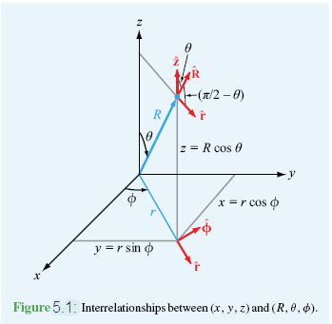
Figure: Interrelationships between $(x,y,z)$ and $(R,θ,ϕ)$

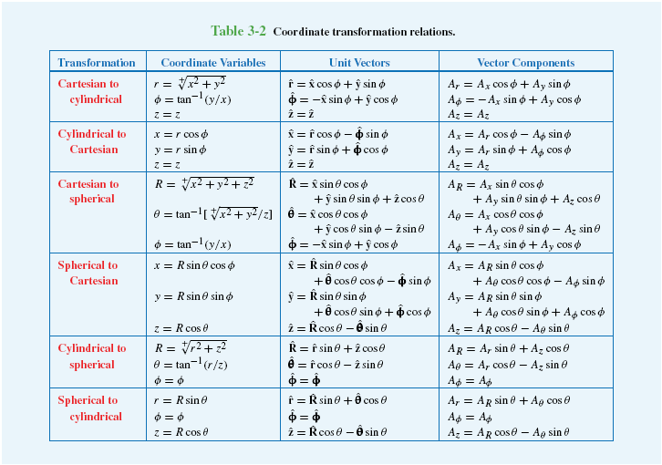

Example 1: Transform $\left(\sqrt{2},\frac{3π}{4},3\right)$ from cylindrical coordinates to Cartesian coordinates.
Solution: $x=r\cos{ϕ=\sqrt{2}\cos{\frac{3π}{4}=-1}}$,
$y=r\sin{ϕ=\sqrt{2}\sin{\frac{3π}{4}=1}}$,
$z=z=3$
So, Cartesian point $\left(x,y,z\right)=(-1,1,3)$

Example 2: Transform $(-1,1,3)$ from Cartesian coordinate to cylindrical coordinate.
Solution: $r=\sqrt{x^{2}+y^{2}}=\sqrt{{\left(-1\right)}^{2}+1^{2}}=\sqrt{2}$
$$ϕ=\tan^{-1}\left(\frac{1}{-1}\right)=\tan^{-1}\left(-1\right)=\frac{3π}{4}$$
$$z=z=3$$

Example 3: Transform $\left(1,0,\sqrt{3}\right)$ from Cartesian coordinate to spherical coordinate.
Solution: $R=\sqrt{x^{2}+y^{2}+z^{2}}=\sqrt{1^{2}+0^{2}+{(\sqrt{3})}^{2}}=\sqrt{4}=2$
$$θ=\tan^{-1}\left(\frac{\sqrt{x^{2}+y^{2}}}{z}\right)=tan^{-1}\left(\frac{\sqrt{1^{2}+0^{2}}}{{(\sqrt{3})}^{2}}\right)=\frac{π}{6}$$
$$ϕ=\tan^{-1}{\frac{y}{x}}=\tan^{-1}{\frac{0}{1}=0}$$
So, the spherical point $\left(R,θ,ϕ\right)=\left(2,\frac{π}{6},0\right)$

Example 4: Transform $\left(2,\frac{π}{6},0\right)$ from spherical coordinate to Cartesian coordinate.
Solution: $x=R\sin{θ\cos{ϕ=2 \sin{\frac{π}{6}}\cos{0=1}}}$
$$y=R\sin{θ\sin{ϕ=2 \sin{\frac{π}{6}}\sin{0=0}}}$$
$$z=R\cos{θ}=2\cos{\frac{π}{6}}=\sqrt{3}$$
So, the Cartesian point $\left(x,y,z\right)=\left(1,0,\sqrt{3}\right)$

Example 5: Transform $\left(2,\frac{π}{6},0\right)$ from spherical coordinate to cylindrical coordinate.
Solution: $r=R\sin{θ=2\sin{\frac{π}{6}}=1}$
$$z=R\cos{θ=2\cos{\frac{π}{6}}=\sqrt{3}}$$
$$ϕ=ϕ=0$$
So, the cylindrical pint $\left(r,z,ϕ\right)=\left(1,\sqrt{3},0\right)$
Example 6: Transform $\left(1,0,\sqrt{3}\right)$ from cylindrical coordinate to spherical coordinate.
Solution: $R=\sqrt{r^{2}+z^{2}}=\sqrt{1^{2}+{\left(\sqrt{3}\right)}^{2}}=2$
$$θ=\tan^{-1}\left(\frac{r}{z}\right)=tan^{-1}\left(\frac{1}{\sqrt{3}}\right)=\frac{π}{6}$$
$$ϕ=ϕ=0$$
So, the spherical point $\left(R,θ,ϕ\right)=\left(2,\frac{π}{6},0\right)$
Example 7: Express vector $\vec{A}=\hat{x}\left(x+y\right)+\hat{y}\left(y-x\right)+\hat{z}z$in spherical coordinate.
Solution: We know in spherical coordinate
$$\vec{A}=\hat{R }A_{R}+\hat{θ}A_{θ}+\hat{ϕ}A_{ϕ}$$
$$A_{R}=A_{x}\sin{θ\cos{ϕ+A_{y}\sin{θ\sin{ϕ+A_{z}\cos{θ}}}} }$$
$$=\left(x+y\right)\sin{θ\cos{ϕ+(y-x)\sin{θ\sin{ϕ+z\cos{θ}}}} }$$
$$=\left(R\sin{θ\cos{ϕ}}+R\sin{θ\sin{ϕ}}\right)\sin{θ\cos{ϕ }}+\left( R\sin{θ\sin{ϕ}}-R\sin{θ\cos{ϕ}}\right)\sin{θ\sin{ϕ}}+ R\cos{θ}\cos{θ}$$
$$=R\sin^{2}{θ}\cos^{2}{ϕ}+R\sin^{2}{θ}\sin{ϕ}\cos{ϕ}+R \sin^{2}{θ}\sin^{2}{ϕ}-R\sin^{2}{θ}\sin{ϕ}\cos{ϕ}+R\cos^{2}{θ}$$
$$=R\sin^{2}{θ}\left(\cos^{2}{ϕ}+\sin^{2}{ϕ}\right)+R\cos^{2}{θ}$$
$$=R\sin^{2}{θ}+R\cos^{2}{θ}=R$$
$$A_{θ}=A_{x}\cos{θ\cos{ϕ+A_{y}\cos{θ\sin{ϕ-A_{z}\sin{θ}}}} }$$
$$=(x+y)\cos{θ\cos{ϕ+(y-x)\cos{θ\sin{ϕ-z\sin{θ}}}} }$$
$$=\left(R\sin{θ\cos{ϕ}}+R\sin{θ\sin{ϕ}}\right)\cos{θ\cos{ϕ }}+\left( R\sin{θ\sin{ϕ}}-R\sin{θ\cos{ϕ}}\right)\cos{θ\sin{ϕ}} -R\sin{θ}\cos{θ}$$
$$=R\sin{θ}\cos{θ\cos^{2}{ϕ}}+R\sin{θ}\cos{θ}\sin{ϕ}\cos{ϕ}+R\sin{θ}\cos{θ\sin^{2}{ϕ}}-R\sin{θ}\cos{θ}\sin{ϕ}\cos{ϕ}-R\sin{θ}\cos{θ}$$
$$= R\sin{θ}\cos{θ({\sin^{2}{ϕ}+cos}^{2}{ϕ}})- R\sin{θ}\cos{θ}$$
$$=0$$
$A_{ϕ}={-A}_{x}\sin{ϕ}+A_{y}\cos{ϕ}$
$$=-\left(x+y\right)\sin{ϕ}+(y-x)\cos{ϕ}$$
$$=-\left(R\sin{θ\cos{ϕ}}+R\sin{θ\sin{ϕ}}\right)\sin{ϕ}+\left( R\sin{θ\sin{ϕ}}-R\sin{θ\cos{ϕ}}\right)\cos{ϕ}$$
$$=-R\sin{θ}\sin{ϕ} \cos{ϕ}-R\sin{θ\sin^{2}{ϕ}}+R\sin{θ\sin{ϕ}}\cos{ϕ}-R\sin{θ\cos^{2}{ϕ}}$$
$$=-R\sin{θ(\sin^{2}{ϕ}}+\cos^{2}{ϕ})=-R\sin{θ}$$
$$∴\vec{A}=\hat{R }R-\hat{ϕ} R\sin{θ}$$
Example 8: Express vector $\vec{A}=\hat{R }R-\hat{ϕ} R\sin{θ}$ in Cartesian form.
Solution: We know in Cartesian coordinate $\vec{A}=\hat{x}A_{x}+\hat{y}A_{y}+\hat{z}A_{z}$
$$A_{x}=A_{R}\sin{θ\cos{ϕ}}+A_{θ}\cos{θ\cos{ϕ }}–A_{ϕ}\sin{ϕ}$$
$$=R\sin{θ\cos{ϕ}}+0.\cos{θ\cos{ϕ }}+R\sin{θ}\sin{ϕ}$$
$=x+y$
$$A_{y}=A_{R}\sin{θ\sin{ϕ}}+A_{θ}\cos{θ\sin{ϕ }}+A_{ϕ}\cos{ϕ}$$
$$=R\sin{θ\sin{ϕ}}+0.\cos{θ\sin{ϕ }}–R\sin{θ}\cos{ϕ}$$
$$=y-x$$
$$A_{z}=A_{R}\cos{θ}-A_{θ}\sin{θ}$$
$$=R\cos{θ}-0.\sin{θ}$$
$$=z$$
$$∴\vec{A}=\hat{x}\left(x+y\right)+\hat{y}\left(y-x\right)+\hat{z}z$$
Example 9: Transform vector $\vec{A}=\hat{x}\left(x+y\right)+\hat{y}\left(y-x\right)+\hat{z}z$ to cylindrical coordinates.
Solution: We know, cylindrical coordinate $\vec{A}=\hat{r}A_{r}+\hat{ϕ}A_{ϕ}+\hat{z}A_{z}$
$$A_{r}=A_{x}\cos{ϕ}+A_{y}\sin{ϕ}=\left(x+y\right)\cos{ϕ}+\left(y-x\right)\sin{ϕ}$$
$$=\left(r\cos{ϕ}+r\sin{ϕ}\right)\cos{ϕ}+\left(r\sin{ϕ}-r\cos{ϕ}\right)\sin{ϕ}$$
$$=r\cos^{2}{ϕ}+r\sin{ϕ}\cos{ϕ}+r\sin^{2}{ϕ}-r\sin{ϕ\cos{ϕ}}$$
$$=r\left(\cos^{2}{ϕ}+\sin^{2}{ϕ}\right)=r$$
$$A_{ϕ}=-A_{x}\sin{ϕ}+A_{y}\cos{ϕ}$$
$$=-\left(x+y\right)\sin{ϕ}+\left(y-x\right)\cos{ϕ}$$
$$=-\left(r\cos{ϕ}+r\sin{ϕ}\right)\sin{ϕ}+\left(r\sin{ϕ}-r\cos{ϕ}\right)\cos{ϕ}$$
$$=-r\cos{ϕ}\sin{ϕ}-r\sin^{2}{ϕ}+r\cos{ϕ}\sin{ϕ}-rcos^{2}{ϕ}$$
$$=-r\left(\sin^{2}{ϕ}+cos^{2}{ϕ}\right)$$
$=-r$
$$A_{z}=z$$
$$∴\vec{A}=\hat{r}r-\hat{ϕ}r+\hat{z}z$$
Example 10: Express vector $\vec{A}=\hat{r} r-\hat{ϕ} r+\hat{z} z$ in Cartesian coordinate.
Solution: We know in Cartesian coordinate $\vec{A}=\hat{x}A_{x}+\hat{y}A_{y}+\hat{z}A_{z}$
$$A_{x}=A_{r}\cos{φ}-A_{φ}\sin{φ}$$
$$=r\cos{φ}+r\sin{φ}$$
$$=x+y$$
$$A_{y}=A_{r}\sin{φ}+A_{φ}\cos{φ}$$
$$=r\sin{φ}-r\cos{φ}$$
$$=y-x$$
$$A_{z}=z$$
Hence, $∴\vec{A}=\hat{x} \left(x+y\right)+\hat{y} \left(y-x \right)+\hat{z} z$
Example 11: Transform the vector $\vec{A}=\hat{r}3\cos{ϕ}-\hat{ϕ}2r+\hat{z}z$ to spherical coordinate.
Solution: We know in spherical coordinate $\vec{A}=\hat{R }A_{R}+\hat{θ}A_{θ}+\hat{ϕ}A_{ϕ}$
$$A_{R}=A_{r}\sin{θ}+A_{z}\cos{θ}$$
$$=3\cos{ϕ}\sin{θ}+z\cos{θ}=3\cos{ϕ}\sin{θ}+R\cos{θ}\cos{θ}$$
$$A_{θ}=A_{r}\cos{θ}-A_{z}\sin{θ}$$
$$=3\cos{ϕ} \cos{θ}-z\sin{θ}=3\cos{ϕ} \cos{θ}-R\cos{θ}\sin{θ}$$
$$A_{ϕ}=A_{ϕ}=-2r=-2R\sin{θ}$$
$$∴\vec{A}=\hat{R }\left(3\cos{ϕ}\sin{θ}+R\cos^{2}{θ}\right)-\hat{θ}2R\sin{θ}+\hat{ϕ}\left(3\cos{ϕ} \cos{θ}-R\cos{θ}\sin{θ}\right)$$
Example 12: Transform the vector at the point to cylindrical coordinates.
Solution: Given that, at the point .
Here,
We get,
Now, from given equation $A_{R}=\cos{φ=-1, A_{θ}=\sin{φ=0, A_{φ}=\sin^{2}{θ=1} }}$
We know,
Hence,
Example 13: Transform the vector . to spherical coordinates.
Solution: Given that ,
Here,
We get,
We know,
Here,
At the point .
Sample exercise-5.1
- Convert the coordinates of the following points from Cartesian to cylindrical and spherical coordinates:
- $p_{1}=(-1, \sqrt{3}, -2\sqrt{3})$ Ans: $\left(2,\frac{2π}{3},-2\sqrt{3}\right)$ and $\left(4,\frac{5π}{6},\frac{2π}{3}\right).$
- $p_{2}=(4, 0, -4)$ Ans: $(4, 0, -4)$ and $\left(4\sqrt{2}, \frac{3π}{4}, 0\right).$
- $p_{3}=(\sqrt{8}, -\sqrt{8}, 4)$ Ans: $\left(4,\frac{7π}{4},4\right)$ and $\left(4\sqrt{2},\frac{π}{4},\frac{7π}{4}\right).$
- Convert the coordinates of the following points from cylindrical to Cartesian and spherical coordinates:
- $p_{1}=(2, \frac{2π}{3},2\sqrt{3})$ Ans: $\left(-1,\sqrt{3},2\sqrt{3}\right)$ and $\left(4, \frac{π}{6}, \frac{2π}{3}\right).$
- $p_{2}=(\sqrt{3}, 0^{0},-1)$ Ans: $(\sqrt{3}, 0,-1)$ and $\left(2,\frac{2π}{3},0\right).$
- $p_{3}=(4\sqrt{3},π,-4)$ Ans: $(-4\sqrt{3}, 0,-4)$ and $\left(8,\frac{2π}{3},π\right).$
- Convert the coordinates of the following points from spherical to Cartesian and cylindrical coordinates:
- $p_{1}=(3, \frac{3π}{4}, \frac{5π}{3})$ Ans: $\left(\frac{3\sqrt{2}}{4}, -\frac{3\sqrt{6}}{4}, \frac{-3}{\sqrt{2}}\right)$ and $\left(\frac{3}{\sqrt{2}}, \frac{5π}{3}, \frac{-3}{\sqrt{2}}\right).$
- $p_{2}=(4,\frac{π}{2},\frac{π}{4})$ Ans: $(2\sqrt{2}, 2\sqrt{2}, 0)$ and $\left(4, \frac{π}{4}, 0\right).$
- $p_{3}=(1, \frac{π}{4},\frac{π}{2})$ Ans: $\left(0,\frac{1}{\sqrt{2}},\frac{1}{\sqrt{2}}\right)$ and $\left(\frac{1}{\sqrt{2}},\frac{π}{2},\frac{1}{\sqrt{2}}\right).$
- Transform the following vectors into cylindrical coordinates at the indicated points:
- $A=\hat{x}\left(x+y\right)+\hat{y}\left(x+y\right)+\hat{z} z at p=(4, 0, -4)$ Ans: $A=4 \hat{r} +4 \hat{ϕ}-4 \hat{z}.$
- $B=\hat{R}\sin{θ}+\hat{θ}\cos{θ}+\hat{ϕ}\cos^{2}{ϕ} at p=(2,\frac{π}{2},\frac{π}{4})$ Ans: $B=\hat{r}+\frac{1}{2}\hat{ϕ}.$
- Transform the following vectors into spherical coordinates at the indicated points:
- $A=\hat{x}y-\hat{y}x at p=(1,-1, 0)$ Ans: $A=-\sqrt{2} \hat{ϕ}$.
- $B=\hat{z}\sin{ϕ} at p=(2,\frac{π}{4},2)$ Ans: $B=\frac{1}{2}\hat{R}-\frac{1}{2}\hat{θ.}$
- Transform the following vectors into cartesian coordinates at the indicated points:
- $A=-\hat{ϕ}R\sin{θ}at p=(1,\frac{π}{2}, 0)$ Ans: $A=-\hat{y}.$
- $B=-\hat{r}\cos{ϕ}-\hat{ϕ}\sin{ϕ}+\hat{z} z at p=(2, \frac{2π}{3},2\sqrt{3})$ Ans: $B=\frac{1}{2}\hat{x}+\frac{\sqrt{3}}{2} \hat{y}+2\sqrt{3} \hat{z} .$

